RACER GUIDE

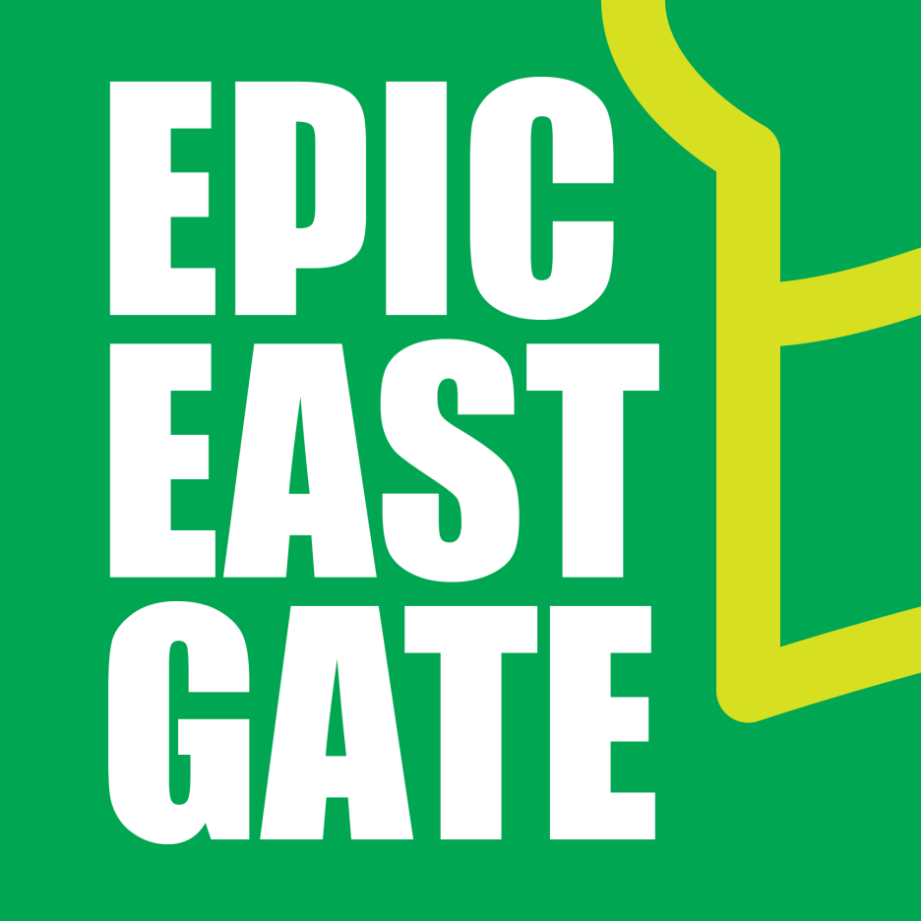

September 20th, 2025

A NOTE FROM YOUR RACE DIRECTOR

THANK YOU!!! First and foremost I want to start from a position of gratitude that you choose this event as one to spend your hard earned money on. In a personal shift over the last number of years I have made a conscious effort to spend less of my time on social media platforms and that has led to a void in the marketing and promotion of this particular event, and yet you come, you spread the word amongst yourselves and you hear from a friend of a friend about this amazing day that gets held on the East Gate Escarpment of RMNP and you put faith in us that despite the lack of promotion it is something you are wanting to experience. So Thank You! For allowing the old school methods of first hand endorsements of our Epic day on the East Escarpment to convince you to come challenge yourself with us.
Epic East Gate is just one event under our umbrella organization of RaceRMNP. RaceRMNP is a series of events brought to you by a committed group of Dauphin Rotarians that married their love for being active and their love for community into some pretty stellar events (if we do say so ourselves) that gives 100% of the money raised back to our community for active living initiatives. Every dollar that you spend to participate in one of our races either goes to cover the expenses to put on the event, or to active living projects that makes recreation more accessible to everyone. We are really proud of that and thank you for choosing to participate in a RaceRMNP event.
For more info on the rest of our events under the RaceRMNP umbrella click here.

A NOTE FROM RIDING MOUNTAIN NATIONAL PARK



Boozhoo / Hello / Bonjour!
Riding Mountain sits within the traditional territory of the Anishinabe People. We are in Treaty 2 territory, which is also at the crossroads of First Nations that belong to Treaty 1 and Treaty 4. Together, Parks Canada and the Coalition of First Nations – the seven First Nations surrounding the park - work to protect and present Riding Mountain National Park (RMNP). Along the trails of this area, you may see prayer flags tied around trees, or tobacco offerings left at the base of trees, or under rocks. Please respect the intention of these gestures of honour and respect toward the land
The Manitoba Escarpment experience is not one to be forgotten! Rising 350 m from the surrounding landscape – about the height of the CN Tower - this land formation is the result of the erosion caused by prehistoric inland seas, glaciation and the ebb and flow of ancient Lake Agassiz. Many aquatic fossils have been found here, buried in the flat, stone layer of shale - which is actually ancient sea-floor sediment.

From the top of the escarpment, watch as white spruce and aspen transition into hardwood forest such as American elm, with understory of ostrich ferns. Box elder, or Manitoba Maple, were once tapped for sap here by Anishinabe of the community now known as Ebb & Flow First Nation. In bur oak savannah, be aware of poison ivy, a common understory plant of this ecosystem. Learn more here: https://www.pc.gc.ca/en/pn-np/mb/riding/securite-safety/ivy

Riding Mountain sees over 200 species of bird pass through or nest during the spring. Nesting bird species such as bluebirds, American redstarts and scarlet tanagers abound on the escarpment. The golden winged warbler, a species recognized as “threatened” by the Species at Risk Act due to habitat loss and hybridization, can be found in this area. RMNP Resource Conservation staff, through efforts such as prescribed burning, create new nesting habitat for this bird. It prefers early-successional habitat such as newly-regenerated, post-burn shrubs interfacing mature forest. Be aware as you run past young stands of beaked hazel or alder that this is prime nesting habitat for the golden-winged warbler; please be extra mindful of low- or ground-level nests. More information on this species at risk can be found here http://sararegistry.gc.ca/species/speciesDetails_e.cfm?sid=942#limits

Wildlife on the escarpment is diverse. While racing, you may encounter a moose browsing on beaked hazel straying from its typical habitat in the boreal uplands, a ruffed grouse tending its nest or a bear feeding on an animal carcass. In any case, safety is of the utmost importance, yours as well as wildlife’s. Making noise on the trail, whether by using noisemakers such as bells, singing, talking loudly or occasionally clapping, will minimize the possibility of surprising animals as you round corners. More information here https://www.pc.gc.ca/en/pn-np/mb/riding/securite-safety/ours-bears-smart

At the start and finish line, the Riding Mountain Park East Gate Registration Complex National Historic Site of Canada – the East Gate – is the gateway to RMNP from the east. A portal leading from agricultural land to woodland, this structure is the last remaining gate of its type in the Parks Canada system. Testament to the efforts of Depression Relief workers, the gate and its Rustic Tudor architecture – seen in the adjacent buildings and found throughout the park - harkens back to the auto-tourism boom of yesteryear. More information can be found at https://www.pc.gc.ca/en/lhn-nhs/mb/eastgate/decouvrir-discover/natcul_2

Now down to the business of Race Day!

Getting There
On Race Day make your way to the Historic East Gate of Riding Mountain National Park. Coordinates are 50.6834 N and 99.55536 W. When travelling on Highway 5 you turn onto Highway 19 (gravel) for 3 miles and you will be at the start line.
*****NOTE**** Highway 19 is a gravel highway and there can be sections of rough travelling (washboard). If coming from Clear Lake, you may be much better served by going South through Erickson and take Provincial Road 357 West to Highway 5 and then North to the East Gate turnoff on Highway 19.
If coming from Winnipeg take Highway 1 to Highway 16 to Neepewa and then turn North onto Highway 5 until you reach the Highway 19 turnoff.

PARKING
Parking will be just East of the main gate complex in a generous private landowners property. As you approach the East Gate from Hwy 5 the parking lot will be on the North side of the road.

VALID FEDERAL PARK PASS REQUIRED
In working with Parks Canada we have arranged to have a Parks agent on site for 7:30-9:30 A.M. anyone with an annual pass is fine or you can purchase your day pass ahead of time at the South Gate to RMNP or at the Admin Building in Wasagaming, otherwise one can be purchased at the start/finish line on race morning for $8.50, cash only. This will primarily be on the honour system but let’s do our best to support our National Park and the amazing work they do preserving and maintaining these locations for all of us to use.

ACCOMODATIONS
- If you are looking to overnight in the Wasagaming/Clear Lake area we encourage you to check out either of our partners, Lakehouse at staylakhouse.ca or Smokey Hollow Resort at smokeyhollow.ca

- There is a campsite in Kelwood that has plenty of room for tents and camper sites as well. This is all on a first come first serve basis. I am told that there is a possibility that the rink may be open that day also to accommodate a hot shower after, consider an additional few bucks to your campsite rental if this is the case.

WAIVERS (paper copy NOT required)
THERE IS NO REQUIRMENT TO PRINT AND BRING A PAPER COPY WITH YOU. The waiver you were required to read and acknowledge at the time of registration will be all that is required.

WASHROOMS
Parks Canada recently built a brand new 2 stall bathroom structure very near the start/finish area to the North of the East Gate. A great improvement over the very old outhouse and porta potties from years past.

Itinerary
7:30 AM race registration opens for 50 KM
8:15 AM 50 KM run meeting and 10 KM registration opens.
8:30 AM 50 KM run starts.
9:15 AM 10 KM run Meeting and 25 KM registration opens.
9:30 AM 10 KM run starts.
9:45 AM 25 KM run meeting.
10:00 AM 25 KM run starts.
3:30 PM 50 KM runners must be through Aid Station A for the 2nd time.
5:30 PM Cut off time for both the 50 and 25 KM runners.

CHECK IN REQUIRMENTS
- One piece of photo ID, no bib transfers allowed
- One smile (nervous or otherwise acceptable)

What You Get
- Distance specific wooden medal
- Epic East Gate Finishers towel
- A RaceRMNP Frisbee
- Farmery Estate Brewery Root- Beer
- Post race soup buffet (a cup of broth, chicken and vegetarian
options and a variety of “fixin’s” to go in it)
- Access to all race day photos at no charge
- Minimum of 1 High Five

Aid Stations
50 KM runners will have an aid station at KM 10, 19, 38.5 and 46.
25 KM runners will have an aid station at KM 10, 12 and 21.
10 KM runners will have an aid station at KM 4 and 6

Each aid station will strive to have the following:
-Gatorade - Water - Coke -Chips -Cookies
- Gummies - Trail Mix -Breaded Perogy Bites -Great Volunteers

There is no substitute for having your own fuel with you, if you know what you like and have trained with it, or have special dietary restrictions bring your desired fuel along.

Course Washrooms
In addition to the washroom facility at the trailhead you will find facilities along the route as follows: there is a washroom at the start of Gorge Creek trail (.6 KM into the race) and at the top of the Gorge Creek trail (6 KM into the race) for 25 KM runners these will be the only washroom facilities while on course.
50 KM runners you will also have access to the washroom at the Breezy Hill Campsite at 30 KM.
10 KM runners you will pass the same outhouse facility at .6 km into your race and .6 km before your finish.
Drop Bags
For 50 KM runners we will allow you to have a reasonably sized drop bag (backpack or smaller) if you wish to bring one, these will be required to be handed in to us prior to the racer meeting and will be waiting for you at Aid Station A which you will pass through at KM 10 and 38.5 and then transported back to the finish line for you. Note that you will need to wait until all runners have gone through Aid Station A for the second time before we will be transporting the bags back to the finish line. If you are a speedy runner you may not want to do a drop bag as it may delay your departure time after you finish.

No Cups
This is a no cup event, we support the request of Parks Canada to keep waste to a minimum and to be cognizant of our environmental impact when we host events. For you this means that you will need to bring your own bottle, vest, cup, chalice, or cupped hands to the aid station with you.
The Animals
You are in a National Park in all its glory, we have Black Bears, Lynx, Bobcats, Wolves, Moose, Deer, Elk and the whole Ark of smaller animals as well. This is something to be excited and amazed about while still having a healthy “fear” so that you take the time to familiarize yourself with what to do should you encounter a bear on the trail. Parks Canada ask that you familiarize yourself with some bear safety tips:

- DO be alert when in areas where bears are likely to be, such as near berry patches and other food sources.
- DO Travel in groups.
- DO make noise. Bear bells, conversation and singing will let the bear know where you are. Bears normally leave an area once they’ve sensed a human.
- DO make your presence known by making noise and waving your arms if you see a bear.
- DO walk away slowly if you surprise a bear nearby.

Perhaps just as or more importantly we ask you to be tick aware. This area is known to be a breeding ground for deer ticks and it is important that you check yourself thoroughly at every opportunity and post-race for ticks. You can learn more about Deer tick safety here: https://parks.canada.ca/voyage-travel/securite-safety/tiques-ticks

Top Finishers
A custom-made East Gate trophy will be awarded to the first, second and third place male and female in the 50 KM 25 KM and 10 KM race.

COURSE MARKING
The trails that we are running are very established and there are little to no social trails within this trail network, therefore we will be clearly marking the intersections of merging trails with signage and in some cases with a volunteer to direct the runners onto the correct trail and then there may be no further markings until the next well-defined intersection. You may see some course tape along the route, this will be used to block off any side trail that has the potential to confuse. (Never go under course tape!)

Mandatory Look Out Points
The 50 KM Runners will have a total of 4 out and backs to look out points along the course. The 25 KM Runners will have 1 out and back. We will aim to have a volunteer at the junction directing you to it and if not then there will be signage indicating that you are to go to the lookout point. At the lookout point there will be an orienteering hole punch attached to a string on a post. Punch your race bib with it and return. At the finish line, the 50 KM runners should have a set of 4 unique hole punches in their race bib, if you are a 25km racer you should have 1 unique hole punched in your race bib.

The 50 KM Course
Start line at East Gate along East Link Trail - .6km
Gorge Creek – 5.5 KM
PERMANENT WASHROOM FACILITY
Highway 19 Westbound - 2.4 km (along Highway 19- gravel road)
Escarpment (a) -1.5 km
FULL AID STATION “A”
Bald Hill (a) – 4.2 km
PARKS CANADA RED CHAIRS
Bald Hill (b) – .8 km
Bald Hill Lookout (out and back- hole punch) – 1.2 km
Reeves Ravine (b) – 2.7 km
AID STATION “B”
J.E.T (c) – 2.0 km
J.E.T (b) 2.1 km
South J.E.T Lookout (out and back – hole punch) – .8 km
North J.E.T Lookout (out and back – hole punch) – 1 km
J.E.T (a) – 5.7 km
Escarpment (c) Northbound - .8
Breezy Hill Campsite (out and back – hole punch) – 3.4 km
Escarpment (c) Southbound - .8
Escarpment (b) – 2.8 km
AID STATION “A”
Bald Hill (a) – 4.2 km
PARKS CANADA RED CHAIRS
Bald Hill (b) – .8 km
(NO BALD HILL LOOKOUT ON 2ND TIME THROUGH)
Reeves Ravine (b) – 2.7 km
AID STATION “B”
Reeves Ravine (a) – 2.5 km
Burls Road (gravel road) – .9 km
East Link to FINISH! - .6 km
TOTAL DISTANCE 50 KM

The 25 KM Course
Start line at East Gate along East Link Trail - .6km
Gorge Creek – 5.5 KM
Highway 19 Westbound - 2.4 km (along Highway 19- gravel road)
Escarpment (a) -1.5 km
AID STATION “A”
Out and back on Escarpment (a) – 2 km (this is on trail already ran to make up distance)
AID STATION “A”
Bald Hill (a) – 4.2 km
PARKS CANADA RED CHAIRS
Bald Hill (b) – .8 km
Bald Hill Lookout (out and back- hole punch) – 1.2 km
Reeves Ravine (b) – 2.7 km
AID STATION “B”
Reeves Ravine (a) – 2.5 km
Burls Road (gravel road) – .9 km
East Link to FINISH! - .6 km
TOTAL DISTANCE 25 KM

The 10 KM Course
Start line at East Gate along East Link Trail - .6km
Burls Road (gravel road) Northbound – .9 km
Reeves Ravine (a) Northbound– 2.5 km
AID STATION “B”
Reeves Ravine (c)Northbound -1 km to turnaround point
Reeves Ravine (c)Southbound – 1 km
AID STATION “B”
Reeves Ravine (a) Southbound– 2.5 km
Burls Road (gravel road) Southbound – .9 km
East Link Trail to Finish - .6 km
TOTAL DISTANCE 10KM

That’s all for now, If you have any questions, email me @ claytonswanton@gmail.com

HAPPY RUNNING EVERYONE!

